Guy Fieri
Chef, restaurateur and TV personality
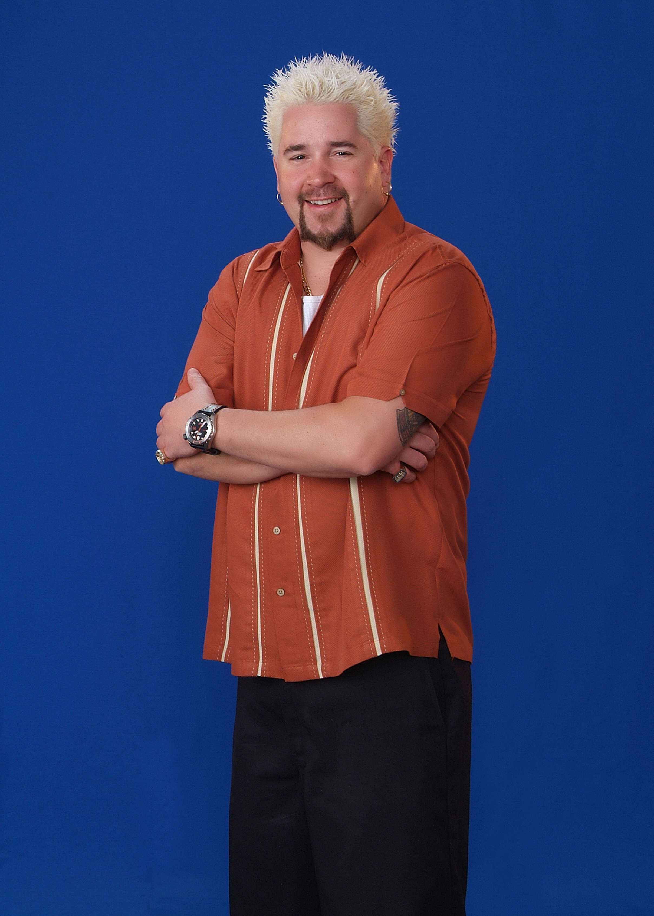
Guy Fieri, the dynamic Food Network “Bad Boy” star, began his culinary career at the tender age of ten, selling pretzels out of a mobile cart in his hometown of Ferndale, California.
Guy now owns four restaurants in Northern California, with a fifth due to open later this year. His first restaurant theme, Johnny Garlic’s, offers up BIG BOLD flavors in an eclectic menu for those with larger than life appetites. Johnny Garlic’s is a Sonoma County homegrown favorite. Guy’s second restaurant genre is Tex Wasabi’s, a fusion restaurant of succulent BBQ, cutting edge and old school sushi. Tex Wasabi’s first location is in Santa Rosa, California, with its second and imminent third location in California’s capitol city of Sacramento.
Guy was the victor of the 2006 ‘Next Food Network Star, and in just two short years has rocketed to the pinnacle of the Food Network world, hosting three very popular Food Network shows; Guy’s Big Bite, Diners, Drive-Ins and Dives, and most recently, co-hosting Ultimate Recipe Showdown. His fun and family friendly persona makes for entertaining and appropriate viewing for all ages.
With Guy’s outgoing and extroverted personality, yet approachable style, he has captured people’s hearts, appetites and imaginations.

###

